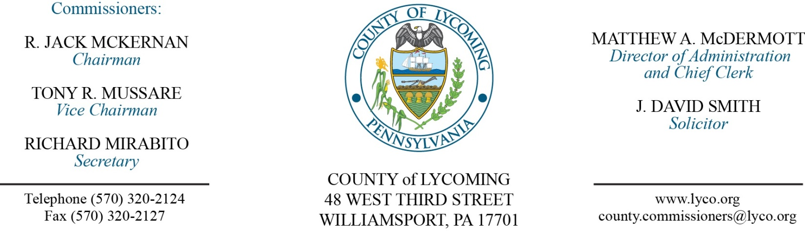
Commissioners’ Meeting Agenda
August 25, 2016

Opening Prayer

Pledge to the Flag

1.0 OPERATIONS

1.1 Convene Commissioners’ meeting.

1.2 Approve the minutes of the previous meetings.

1.3 Receive public comments (agenda items only).

2.0 ACTION ITEMS

2.1 Enact Ordinance 2016-02 for guarantee of LCWSA bond. (Christine Weigle/Chris Brewer)

2.2 Approve professional service agreement with, Aaron Biichle Esq for Conflict Attorney services not to exceed $35,000 annually. (Mya Toon)

2.3 Approve purchase of IT equipment for the White Deer Golf Course in the amount of $20,506.25. (Mya Toon)

2.4 Approve memorandum of understanding with Lycoming County Housing Authority for environmental review. (Mya Toon)

2.5 Approve purchase from Lezzer Commercial Door in the amount of $10,929.20 for the main entrance doors at PRC. (Ken George)

2.6 Approve purchase from Cleveland Brothers Equipment Company, Inc., for 1- New 2016 Caterpillar D6T LGP Track Type Tractor with accessories, with the trade-in for the total amount of $373,475. (Jason Yorks)

2.7 Approve 2015 Flood Mitigation Assistance Grant Program agreement with PEMA in the amount of $1,233,850. (Josh Schnitzlein)

2.8 Approve professional services agreement with Dr. Gregory R. Frailey for LTS Regional Medical Director not to exceed $2,000/annually. (Wendy Hastings)

2.9 Approve the following personnel action: (Roxanne Grieco)
PCD – David L. Hubbard as full time replacement Zoning Officer – Pay grade 6 - $32,001.58/annually effective 9/11/16

2.10 Accept Human Resources report through 8/31/16. (Roxanne Grieco)

6.0 PUBLIC COMMENT:

7.0 NEXT REGULARLY SCHEDULED MEETING: Planning Session on Tuesday, August 30, 2016.

8.0 ADJOURN COMMISSIONERS’ MEETING.

